IPOPI - ASID
5th ASID Biannual Congress
IPOPI Regional African Patients Meeting
AVANI Hotel Livingstone, Zambia
31st March to 4th April 2017
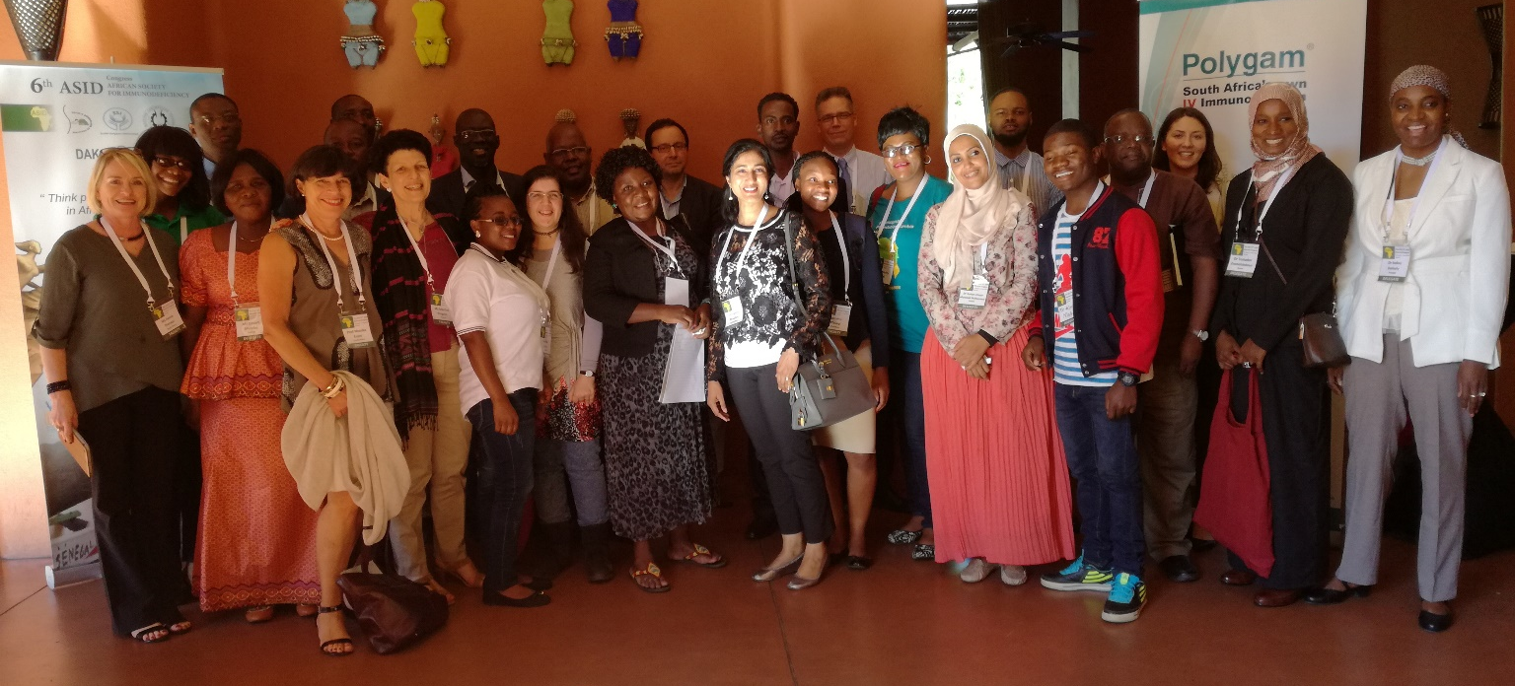

Report

Introduction

The 5th ASID Biannual Congress took place in Avani Congress Hotel Livingstone in 31st of March to 4th of April. This Scientific Congress was hosted by the ASID presidential country Zambia and brought together experts in immunology from the region but also some leading names in the field from overseas to discuss recent developments in immunology and allergy. The Congress theme was “Towards Enhanced Care of Children with Primary Immune Deficiencies and Allergy in Africa” and aimed in sharing vast experiences in basic and clinical science and promoting evidence-based management for Primary Immunodeficiencies (PIDs) in the African continent.

IPOPI Regional African meeting was organised back to back with the ASID Congress on the 2nd of April. This meeting was divided into three sessions and brought together PID patients and patient representatives from six African countries. It offered an opportunity for the patients in the region – many of whom had never met another PID patient before– to interact, exchange experiences and find inspiration from each other for their national campaigning towards better care in their countries. Educational lectures were also held for the patient representatives to promote better understanding and expertise of their conditions. The patients meeting was sponsored with an unrestricted grant from National Bioproducts Institute (NBI).

ASID Biannual Congress

The two-and-a-half-day Congress was scientific in nature. The Congress started with a pre-congress clinical workshop dedicated to flow cytometry and its applications for PID diagnosis. The actual Congress opened after the workshop with welcome addresses by ASID President Prof James Chipeta, Chairperson for ESID Registry Dr Nizar Mahlaoui, IPOPI Vice-president Mrs Martine Pergent and INGID Treasurer Mrs Dorothea Grosse-Kreul. The welcoming words were followed by a keynote speech from Prof Jules Alao, Benin on behalf of Prof Aziz Bousfiha who was unable to attend the Congress and the Guest of Honour, representative from the Zambian Health Ministry. The welcoming notes stressed the issue of very low diagnosis rates in the continent with 99 percent of African patients remaining undiagnosed and with 50 percent of countries having no reported cases of PIDs up to this day. All keynote speakers expressed their delight of having the opportunity to discuss the obvious challenges facing primary immunodeficiencies in Africa and the next steps in the pursuit of reaching better levels of diagnosis, availability to treatments and awareness in the continent.

The first day of the Congress was dedicated to the topic of “PIDs and Allergy in the World and in Africa - The Differences”. The second Congress day topic was “The plight of children with PIDs and Allergy in Africa: Diagnosis and Management” and the final day addressed allergies in Africa. The Congress scientific lectures discussed both novel advances in immunology globally and regional priorities and specificities of PIDs in Africa. After each session of the congress there was either a Q&A session or a panel discussion on the topics addressed. Not only did the topics of the presentations discuss developments and research in medical field they also touched some other topics such as the socioeconomic differences and access to treatments in Africa.

Each day of the Congress had a dedicated abstract session where a number of recent studies in PID and allergy were presented. IPOPI had the honour of presenting their abstract poster on “Potential for Management of Primary Immunodeficiencies (PIDs) in Africa – A Comparison with Haemophilia” that was presented by IPOPI Vice President Ms Martine Pergent and that addressed the similarities of the two conditions yet the differences in the levels of awareness, the access to treatments –and the number of Patient organisations- in Africa.

IPOPI Regional PID Patients Meeting

IPOPI Regional PID Patients meeting was organised in parallel with the Congress on the 2nd of April. The Meeting consisted of three sessions and was attended by PID and haemophilia patient representatives from Zambia, Namibia, South Africa, Sudan, Morocco and Senegal as well as immunologists, allergists, medical students and company representatives from many more countries in Africa and other parts of the world.

Session 1 was dedicated to introductions and hearing patient testimonies from the participants. During the session, the participants exchanged experiences and discussed the particularities of challenges in access to treatment and awareness in their respective countries. PID patient testimonies from South Africa, Zambia and Sudan, testimonies from haemophilia societies from Zambia and Namibia and one testimony from a medical student from Zimbabwe were heard during the session. It was concluded that even though the countries have huge differences in levels of care there is a clear need for awareness and advocacy work in all countries. The participants agreed that the experience from other countries and the haemophilia society’s progresses show that patient organisations are the best advocators for this and the countries that do not yet have a patient organisation should take action to establish one in the near future.

Session 2 was dedicated to presentations about experiences from already existing patient organisations in the region and other parts of the world as well as hearing physician testimonies. The session was opened by ASID President Prof James Chipeta, who expressed his gratitude towards IPOPI for organising this event in parallel with the Congress, bringing patients from the region together and helping ASID in the work towards better care and awareness for Primary Immunodeficiencies in Africa.

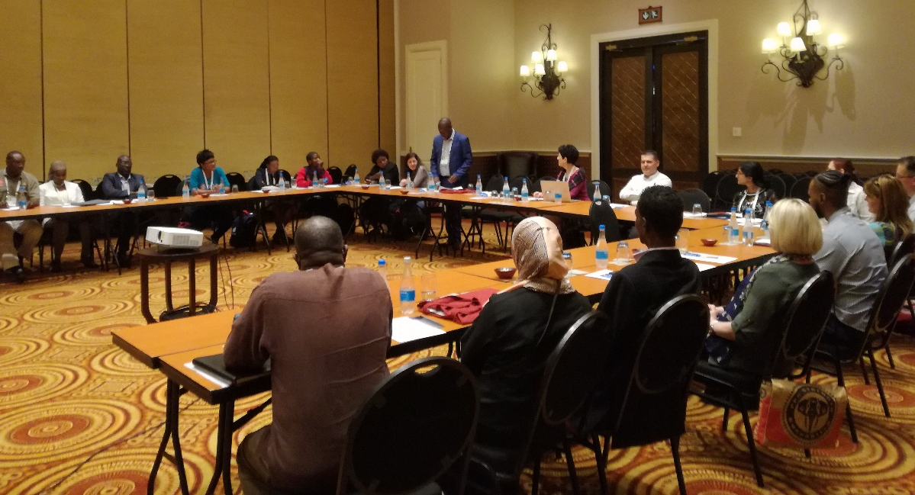
The next opening remark was given by Mr Keith Simbotwe, president of the newly formed Zambian PID pa-tients organisation. He thanked IPOPI for the invitation and support to attend the congress and expressed his hope to start a fruitful collaboration bet-ween the Zambian society for PID patients and IPOPI. He extended his thanks to the Zambian medical team who has been successful in driving the patients to come together in the country and offer them support and advise.

IPOPI Board member and President of the South African patient organisation PiNSA, Ms Annie Pienaar, gave a presentation on advocacy work and campaigning the organisation has done in her country. She highlighted the importance of collaboration between PID stakeholders and the need for one unified patient organisation and one national patient registry per country. Her presentation gave a good example from the region but also the challenges faced by PID patients even in the more developed countries in Africa.

IPOPI Vice President Ms Martine Pergent welcomed all the participants on behalf of IPOPI and thanked National Bioproducts Institute (NBI) for sponsoring the regional patients meeting. She then proceeded to talk about the potential of patient organisations in making a difference in PID management. She gave an overview of the main challenges facing African PID patients and proposed that the next step for African countries will be to establish an active patient group to work to overcome these challenges. IPOPI NMO Programmes Officer Ms Saara Kiema followed by giving an overview of the successful work of IPOPI NMOs from other countries in the developing world.

Ms Charity Pikity, President of the Zambia Haemohilia Society gave a presentation about the successful advocacy and awareness work of another rare disease patient organisation in the region. She talked about the approaches taken by her community in Zambia and the great developments derived from these initiatives. For example, haemophilia has still a stigma of witchcraft which the society has approached by training the traditional healers in rural parts of the country. They have also been successful in reaching out to the Health Ministry of the country to raise awareness on higher level. She expressed her sincere support towards the PID society in Zambia and hopes for cooperative actions in the future with also other rare diseases.

After the patient perspectives, a number of physician testimonies were heard touching the subject of the importance of national patient organisations. Dr Leila Jeddane on behalf of Prof Aziz Bousfiha from Morocco, Prof Tandakha Dieye from Senegal, Dr Monika Esser from South Africa and Prof Ridha Barbouche from Tunisia gave their views on why it is important from a doctor’s perspective also to have an active patient group for PIDs and the importance to work together. The common conclusion of these leading physicians in immunology in Africa was that the experience in other regions shows that with joint efforts the united voice of PID patients can help to accomplish better awareness, diagnosis and essentially better life quality and access to therapies, among them IG and BMT.
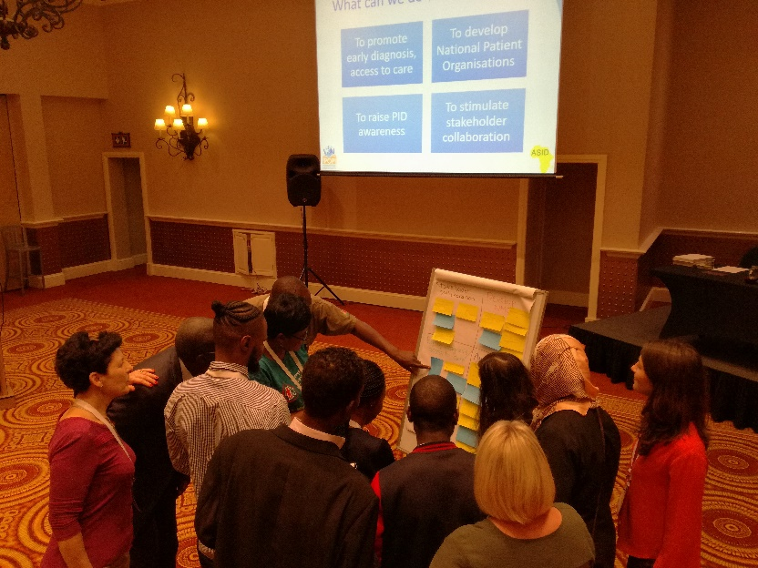

Session 3 was dedicated to a patient workshop to discuss the regional priorities of the patient organisation. The priorities discussed were stakeholder collaboration, developing NMOs, early diagnosis, access to care and awareness.

The patient representatives discussed the priorities in small groups and looked for solutions, next steps and actions to be taken on the national level. The session resulted in agreeing on the key actions regarding the priorities.

Stakeholder Collaboration  - Collaborate with GPs  - Reach out to Ministries of Health  - Other rare diseases  - Traditional healers and village headmen | Develop NMOs  - Identify and communicate with patients in the country  - Put up a patient group  - Legal status for NMO
Early diagnosis and access to care  - Training primary care takers  - Laboratories facilities  - Data collection/registry | Awareness  - Workshops, national campaigns  - Social media  - Visual materials  - Public figure to promote PIDs  - Reach out medical students
Table: Patient workshop conclusions: The main regional priorities

Conclusion

IPOPI took part in a number of discussions taking place during the Congress about identifying the next steps in the region to be taken by the PID stakeholders. IPOPI strongly stated several facts alongside The Principles of care such as the need of data (which means national registries), the needs of expertise centres, and the importance of a strong collaboration between stakeholders.
A Call to Action, Primary Immunodeficiencies in Africa: Improve Diagnosis and Treatment for Patients was developed and launched in cooperation between IPOPI and ASID. To this day, the petition has reached 194 supporting signatures from Africa and other parts of the world, among them ASID, ESID, INGID.
After the congress IPOPI developed a press release translated into three languages in cooperation with ASID to help stakeholders to raise awareness among decision makers in African countries on a national level. IPOPI is also hopeful that resulting from the fruitful discussions with the invited African patient representatives there will be many new IPOPI NMOs formed in the near future.

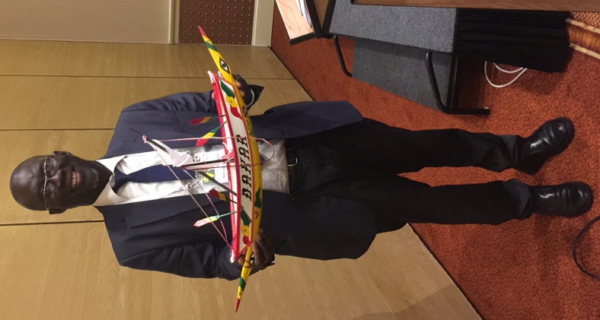
A conclusion deriving from the discussions and IPOPI sessions was that even though it is easy to speak about the work still to be done in Africa it is also important to see the situation in light of history and the developments that Africa has gone through in Immunology in the last ten years. With dedicated and cooperative work, there is a lot that can be reached in terms of PID awareness, diagnosis, treatments and registries in the near future. ASID has expressed its strong will to a continued collaboration with IPOPI and hopes that IPOPI will be able to organise more regional patient events back to back with ASID A-projects. IPOPI has proposed to work with the different stakeholders on a Plan for AFRICA and will be early involved in the next Biannual Congress in Dakar, Senegal.

